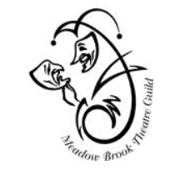
MEADOW BROOK THEATRE GUILD MEMBERSHIP FORM
The Guild
P.O. Box 80933
Rochester, MI 48308

Please return completed form with your check payable to The Guild.
Member Name will appear in Meadow Brook Theatre Play Bills.
Provide your information as you would like it to appear in The Guild Directory.

Date: _______________________________________________________________________________

Name:____________________________________________________________________________________

Address: __________________________________________________________________________________

City/State/Zip: ______________________________________________________________________________

Home Phone: ___________________________Cell Phone:_________________________________________

Email: ____________________________________________________________________________________

Birthday Month/Day: ________________________________________________________________________

Spouse’s Name (Optional):____________________________________________________________________

Special Interest or Skills(sewing, reading, hiking, photography, mahjong, golfing, event planning…):

_________________________________________________________________________________________

If you are familiar with computer applications such as Photo Shop, Excel, Canva, MS Word etc. and are willing to share your skills please list the applications:

_________________________________________________________________________________________

Send completed form and $50.00 annual Dues (can be pro-rated) to The Guild, Attention Speedy Bates, P.O. Box 80933, Rochester, MI 48308.

Any questions please email MBTGuild@gmail.com or leave voice mail at 248-370-4244.

